CDK Google Analytics Website Event Glossary

January 2019

Google Analytics & Your Website Events

Google Analytics is a great platform to be able to visualize the different channels people use to visit your website. You can track which campaigns, links or industry websites are sending you traffic, see how long they spent on your site, and what pages they may have exited the site from.

Google Analytics also allows you to track what your customers are doing when they are on your website. Form submissions, inventory searches, click to call on mobile – all of these actions can be tracked as an event in Google Analytics. Google Analytics defines an event as a user’s interaction with a web page element.

In an effort to promote transparency with dealer data in Google Analytics, CDK is now pushing a set of website engagement metrics into any Google Analytics account installed on a dealer website. We hope that with pushing these events, dealers can continue to leverage their own website data in Google Analytics to make decisions about their marketing dollar.
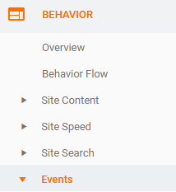

To see your website events, head into the “Behavior” section of Google Analytics and then click into “Events” to load the overview of events. Click into “view full report” to see all of the categories of different events happening on your website.

If you click into one of those catgories, you will see the event action as “click.” Click into the action and you will see the event label as the page the event occurred on.

The following glossary will give you a description of each event catgory CDK is passing to your Google Analytics account. We’ve also provided a gallery of goals to install in your Google Analytics account. Remember you can only have 20 active goals in Google Analytics. Finally, we hav provided some dashboards to help view metrics for certain pages on your site.

CDK Global Google Analytics Event Library Glossary
Inventory Search: A page view when a user lands on a vehicle search results URL or click when the user changes the filters of the vehicle search results to see inventory.

Vehicle Interactions: A click into saved vehicles, window sticker, photo galleries, payment calculator or vehicle specifications. These occur on the Vehicle Search Results or Vehicle Details Page.

Site Navigation: A user clicks a link in your navigation.

Form Open: This occurs when any page with a form loads, or a pop up form opens.

Form Initialized: This event occurs when the user engages with a section of the form.

Form Submit: Submission of a form on the website. (Note: this is not scrubbed for spam leads or test leads that were submitted.)

Form Success: The number of successful leads submitted on the website. This is the closer number to the leads you may see in your CRM or CDK Insights.

Form Errors: Occurs when the form submit event returns an error. A high number of errors on a single form may be a reason to look at how that form is configured.

Site Search Term: The number of site searches that occurred.

Click to Call: The number of times a user clicks on one of the phone numbers in your website header to call the dealership. This includes the combination of both sales and service calls.

Header: The number of times the user clicked your website header, other than the click to call total.

Footer: The number of times a user clicked a link in your footer. Each website can configure the footer links differently. Google Analytics will show you which footer links were clicked.

Model Research: The number of clicks on either the model showroom page or the model details page.

Hours and Directions: The number of clicks that link to the Hours and Directions page or map link.

Similar Vehicles: The number of clicks on the similar vehicles card.

Service and Parts: The number of clicks navigating to the “Service and Parts Specials” page.

Special Offers: The number of clicks navigating to the standard “specials” page on a website.

CDK Global Google Analytics Dashboards to View Events
In order to make viewing these engagement metrics easier in your Google Analytics account, we have created 4 dashboards to help view this data.

To install any of these dashboards to your Google Analytics account, click on the link and accept the importing of the dashboard. From there, you access any of the dashboards under customization.

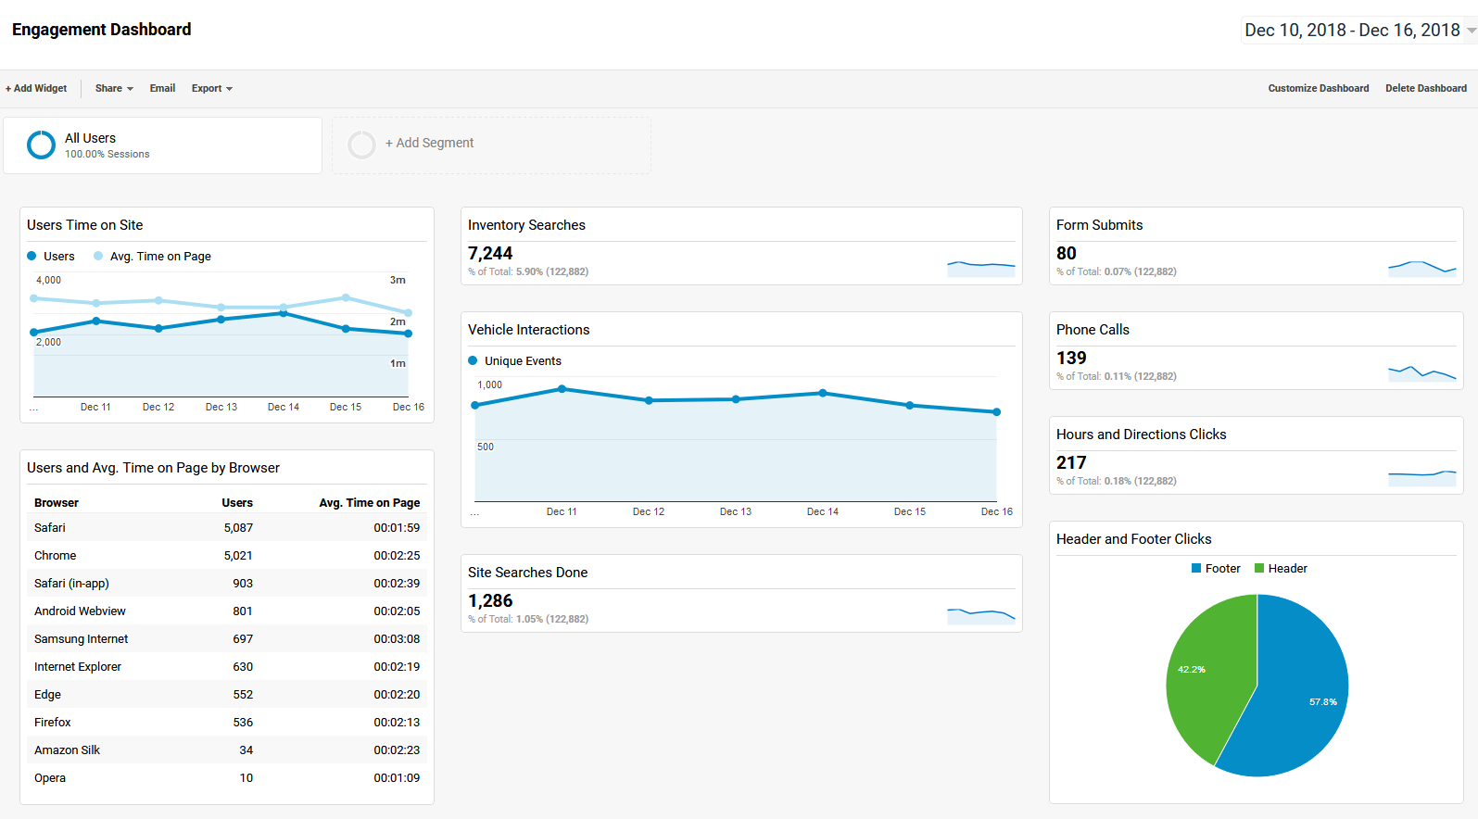

Engagement Dashboard
Vehicle Details Engagement Dashboard
Vehicle Details Engagement Dashboard
Form Submission Dashboard

CDK Global Google Analytics Goal Library
Once you know the events installed on your website, it’s best to create goals for those events. That way, you are able to see in Google Analytics every time someone completes an action, such as a click to Hours and Directions, and compare traffic based on the goals of your dealership. The link below will install all 14 goals into your Google Analytics library. Since you only have the ability to do 20 live goals, you may need to re-assign some goals if you want to use all 14.

Google Analytics - Full Goal Library

If you want to install just one of those goals, the link and description are in the table below.

Google Analytics Goal - Form Open

Google Analytics Goal - Form Submits
Google Analytics Goal - Vehicle Interaction on Vehicle Details
Google Analytics Goal - Click to Call - on mobile website sum of calls
Google Analytics Goal - Model Research - clicks into Model Details or Model Showroom
Google Analytics Goal - Site Search Completed by user
Google Analytics Goal - user clicks on the specials card (any page)
Google Analytics Goal - Compare Vehicles Click (on VSR)
Google Analytics Goal - Inventory Search (on VSR)
Google Analytics Goal - Vehicle Interaction on Vehicle Search Results
Google Analytics Goal - Hours and Directions (Page Visit or Click on Map Linkout in Header)
Google Analytics Goal - Click into Header or Footer (any page)
Google Analytics Goal - Navigation Click

